VOLUNTEER APPLICATION
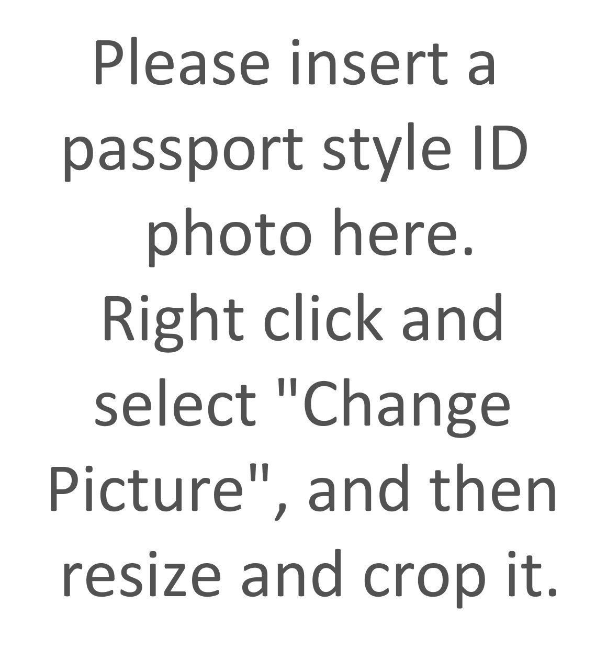
Name: |  |  |  | Date of Birth:  (DD/MM/YYYY)
Address:
 |  |  |  | Post code:
Telephone: |  |  |  | Mobile:
Emergency Contact No: |  |  |  | Relationship to Contact:
Email:
COVID-19 vaccination – have you had your 1st jab? |  |  |  |  |  |  | 2nd jab?
Booster jab?
Do you have any health issues that may affect your volunteering with us?
If yes please give details:
Please list any hobbies, interests or skills you have that you would be willing to share with the club:
Can you tell us about your experience, work, education, volunteering or in other areas of life especially any experience of being with vulnerable adults.
Please list any training you would like to undertake:
If you become a volunteer we will need to carry out a Criminal Records Check (CRB) on you (Exceptions order 1975). Having a criminal record will not necessarily prevent you from becoming a volunteer with us.
Do you do have a criminal record?

If yes please give details:
Personal Referees:
Please give us contact details of two people who know you well, preferably for at least two years. They must not be relatives.
 |  | Referee 1 |  |  |  | Referee 2
Ms/Miss/Mrs/Mr |  |  | Ms/Miss/Mrs/Mr
Name: |  |  | Name:
Address: |  |  | Address:
Telephone |  |  | Telephone
Email: |  |  | Email:
Occupation |  |  | Occupation
Capacity in which  They know you and  For how long: |  |  | Capacity in which  They know you and  For how long:
The information given in this form is correct to the best of my knowledge and belief.
Signature: |  |  |  | Date:
Data Protection Act: I understand and agree that as part of volunteering with Bath Gateway Out & About my details may be held in a confidential database that is only used for reasons relating to my volunteering.
Signature: |  |  |  | Date:
Thank you for your interest in becoming a volunteer at Bath Gateway Out and About club.
Please return this form to me by email or post at the address at the bottom of this page I will contact you shortly.
If you have any questions please don’t hesitate to contact me.
I look forward to meeting you soon.
Becky Morgan

If you are printing this form out and filling it in by hand, please attach your passport style photo using glue or Sellotape in the place where it says: "Please insert a passport style ID photo here…", etc.

Or, if you have any problems doing that (or with uploading a photo of yourself in Microsoft Word), please send your photo separately, e.g., as an image file attachment in an email message. Thank you.

